
Hampton Middle School
PTSO Meeting

Wednesday, November 5, 2025
PTSO Secretary, conducted the roll call. The following persons were present:
PTSO Board Members Present:
Angela Butler – President (absent)
Jamilya Mayo-McAllister- Secretary
Damaris Disen- Treasurer
Shiona Bullock- SACI Representative
Attendees: Rachel, Ana Chavez, James, Lauranse, Dwayne Carey, Shayna Simer, and Zachary Callaghan.
Administrators Present: Mrs. Mitchell, De’Shauna Thornton, Antiolla Anderson, Dr. Donald Armstrong.
Summary of Previous Meeting Notes - Jamilya Mayo McAllister, Secretary
PTSO Goals for 2025-26
- Increase PTSO Membership, Teacher, Parents, and Students are welcome to join Dues are $10 per family. Checks got to Hampton Middle School PTSO.
- Create a Hampton PTSO Facebook Page- this page will be used to post PTSO information, PTSO fundraisers, and various events.
- PTSO Spirit Nights for Sept. and Oct. were at Nando’s Peri Peri and Panera Bread
- PTSO gave a $25 gift card to the first parent to pay their PTSO dues.
- PTSO gave gift cards to new Hampton Middle School Teachers.
Superintendent Advisory Council Update – Shiona Bullock, SACI Representative
- October 9 meeting covered PAC overview and Vision 2030.
- Next meeting Nov. 13 featuring guest speaker, Dr. McDade. She will provide a State of Schools update
- Please submit any questions you have surrounding Instructional shifts AI and Technology for the December meeting.
- Meetings are held at the Edward L. Kelly Leadership Center on the 2nd Thursday of each month, 6pm-8pm.
Financial Report- Demaris Disen, Treasurer
- PTSO Goal for FY25-26: $3,000
- Beginning balance, as of Oct 1st: $ 1,266.36
- Fundraiser Results:
  - Panera Bread Spirit Night $ 129.65 (AR)
  - Nando’s Spirit Night $ 396.76
  - End balance: $1,792.77
PTSO Donations:
New Teacher Gift Cards-$140
Gift Cards for PTSO Member Winner: $25.00
Upcoming Events: Jamilya McAllister, Secretary
PTSO Fundraisers:
- PTSO Movie Night- December 17th, 6:30 PM - 8:30 PM
  - Free admission for Movie Night with options to purchase cash food concessions. All proceeds will support future PTSO initiatives
  - Poll to be sent to students to vote on the holiday movie on Monday, Nov 24th
  - Flyer to be sent out to parents by Monday, December 1st to RSVP to Movie Nigh
PTSO Spirit Nights:
- Jersey Mike- November 13th
- Chipotle Spirit Night- December 9th
PTSO Board Updates: Jamilya McAllister, Secretary
- Can Food Drive ends on Nov. 7th

- Clothing Drive-Nov. 3rd- Dec. 5th
- Donations can be dropped off in box at the front office.
- PWCS Family Engagement Info. will be posted on bulletin board next to the front office. Please reach out to Mrs. Cargill for more information.
- Next Meeting is Wednesday, Dec. 3rd

Principal’s Report- Mrs. Mitchell, Hampton Middle School Principal
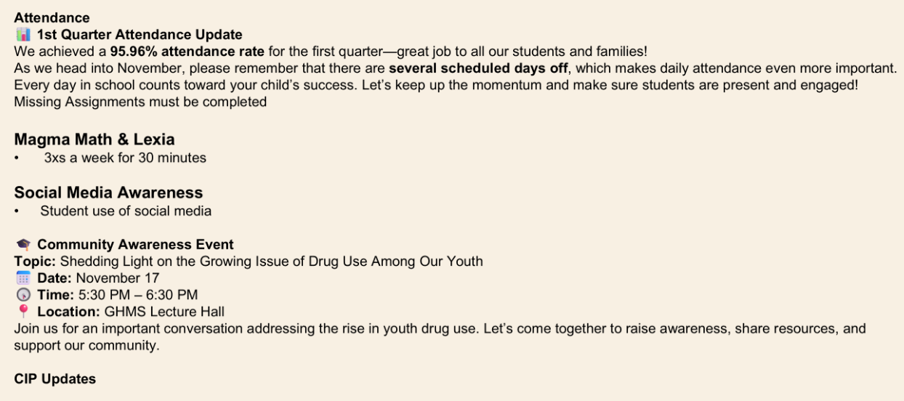
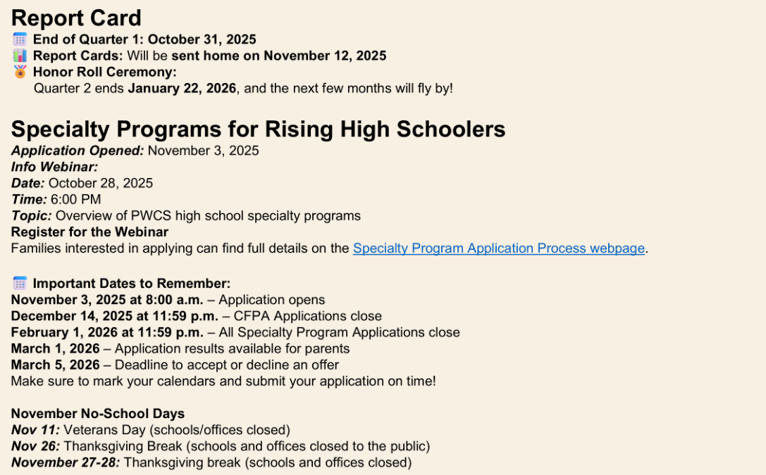
PTSO Meeting Dates for FY2025-26 School Year:
- Wednesday, Nov. 5th
- Wednesday, Dec. 3rd
- Wednesday, Jan. 7th
- Wednesday, Feb. 4th
- Wednesday, Mar. 4th
- Wednesday, April 1st
- Wednesday, May 6th
- Wednesday, June 3rd

