
Hampton Middle School
PTSO Meeting

Wednesday, March 4, 2026

PTSO Secretary, conducted the roll call. The following persons were present:
PTSO Board Members Present:
Angela Butler – President
Jamilya Mayo-McAllister- Secretary
Damaris Disen- Treasurer
Shiona Bullock- SACI Representative
Attendees: HH, Lourdes Aranda, Patricia Sorto, Nel, Thiem Nguyen, Valerie Plummer, Zachary Callaghan, Brahimi, Fahima Shams.
Administrators Present: De’Shauna Thornton, Donald Armstrong, and Mrs. Frazier.
Summary of Previous Meeting Notes - Jamilya Mayo McAllister, Secretary
PTSO Goals for 2025-26
- Increase PTSO Membership, Teacher, Parents, and Students are welcome to join Dues are $10 per family. Checks got to Hampton Middle School PTSO.
Thanks for your support with our Spirit Nights:
- Panera Bread –Oct. 16th
- Jersey Mike- November 13th
- Chipotle Spirit Night- December 9th
- Chick-Fil-A Spirit Night- January 21st
- Urban Air- February 12th
Thank you for all the parents and students that participated in our Valentines’ Day Candy Sales. We appreciate your support!

Superintendent Advisory Council Update – Shiona Bullock, SACI Representative
- The February meeting was held on 2/12/2026. We discussed the grading policy and student resources and services including gifted, special education, and multilingual services. 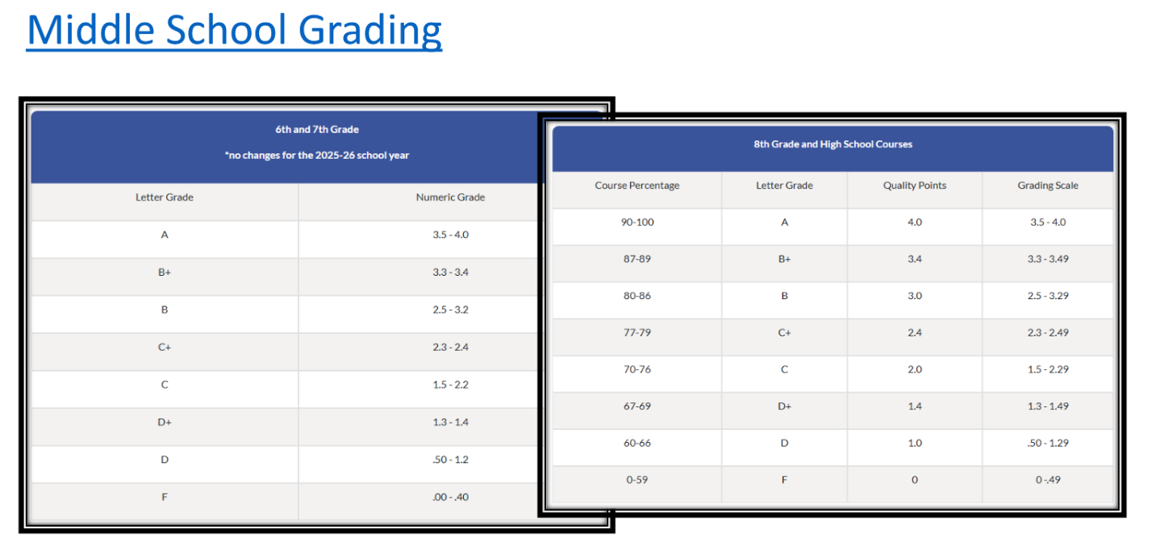
- The assessment and grading practices is policy 661 in the Policies and Regulations Handbook (https://go.boarddocs.com/vsba/pwcs/Board.nsf/goto?open&id=A2X3H5668571)
- The March meeting will be held on Thursday, March 12. We will discuss the Budget and Capital Improvement Plan.

Financial Report- Demaris Disen, Treasurer
PTSO Goal for FY25-26: $3,000.00

Beginning balance, as of Feb 1st: $ 2,115.06
Income:
PTSO Membership $10.00
Candygram Sales $793.25
Donation $11.47

Accounts Receivable:
Urban Air fundraiser $268.72
Total Income: $1,083.44

Expenses:
Candy & Supplies $446.47

End balance, as of Feb. 28th: $ 2,752.03

Upcoming Events: Jamilya McAllister, Secretary
PTSO Fundraisers:
- Candy Grams -
  - 2025 - (62) deliveries - Sales: $315
  - 2026 (125) deliveries - Sales: $793.25
- Future Focus
  - Administrative Professionals’ Day - April 22nd
  - National School Principals Day - May 1st
  - Teacher Appreciation Week - May 4th - 8th
- Survey for future events - follow-up
  - Mother/Daughter Tea
  - Father/Daughter Dance
  - Father/Son Basketball Tournament
  - Father/Son Luncheon
PTSO Spirit Nights:
- March 20th - Pizza: 11 AM-9 PM
- April 14th - Nando’s Peri Peri, 4-9 pm

Next PTSO Meeting: April 8th, 5:30 pm on Zoom
PTSO Board Updates: Jamilya McAllister, Secretary
Upcoming PTSO Spirit Nights:
- March 20th - &Pizza: 11 AM-9 PM
- April 15th- Nando’s Peri Peri , 4-9 pm

Events PTSO Board is Considering:
- Partnering with 21st Century at Family Dinner

Principal’s Report- Mrs. Frazier, Hampton Middle School Principal
- IB Evaluation Postponed until April 9th
- Saturday School
- 21st Century
- All in Tutoring
- Test Nav
- SOL Released Test

https://www.doe.virginia.gov/teaching-learning-assessment/student-assessment/sol-practice-items-all-subjects#Practice

Hampton Events:

Citizen’s Time:
- What’s an event that includes Mothers and Sons, Father and Daughters.

PTSO Meeting Dates for FY2025-26 School Year:
- Wednesday, April 8th
- Wednesday, May 6th
- Wednesday, June 3rd

